**ABSTRACT**

*The paper explains the working of an Uber dataset, which contains data produced by Uber for Russia . Uber is defined as a P2P platform. The platform links you to drivers who can take you to your destination. The dataset includes primary data on Uber pickups with details including the date, time of the ride as well as longitude-latitude information, Using the information, the paper explains the use of the classification algorithm on the set of data and classify the various parts of Russia . Since the industry is booming and expected to grow shortly. Effective taxi dispatching will facilitate each driver and passenger to reduce the wait time to seek out one another. The model is employed to predict the demand on points of the Russia.*

**TABLE OF CONTENTS**

* Introduction 8
* Importing Dataset 8
* Data cleaning 9
* Data Profiling 9-10
* Data Pre-processing 10
* Data Visualization 11
* Date-time Operation 13
* Code & Screenshot
* Conclusion

**INTRODUCTION**

 We will use [Python](https://www.geeksforgeeks.org/python-programming-language/) and its different libraries to complete the uber data analysis

**WHAT LIBRARIES WE USED**

## **Importing Libraries**

The analysis will be done using the following libraries :

* [Pandas](https://www.geeksforgeeks.org/python-pandas-dataframe/):  This library helps to load the data frame in a 2D array format and has multiple functions to perform analysis tasks in one go.
* [NumPy](https://www.geeksforgeeks.org/python-numpy/): NumPy arrays are very fast and can perform large computations in a very short time.
* [Matplotlib](https://www.geeksforgeeks.org/matplotlib-tutorial/) / [Seaborn](https://www.geeksforgeeks.org/introduction-to-seaborn-python/): This library is used to draw visualizations.
* Plotly: Plotly is a free and open-source graphing library for Python.
* Matplot3D : The mplot3d toolkit adds simple 3D plotting capabilities to matplotlib by supplying an axes object that can create a 2D projection of a 3Dscene

To importing all these libraries, we can use the  below code :

|  |
| --- |
| **import pandas as pd**  **import numpy as np**  **import matplotlib.pyplot as plt**  **import seaborn as sns**  **import plotly.graph\_objects as go**  **from mpl\_toolkits.mplot3D import Axes3D** |

## **Importing Dataset**

After importing all the libraries , you can import the dataset using the pandas library.

|  |
| --- |
| dataset **=** pd.read\_csv("uber\_dataset.csv")  dataset.head() |

**So after importing the datasets the output we get is : -**

**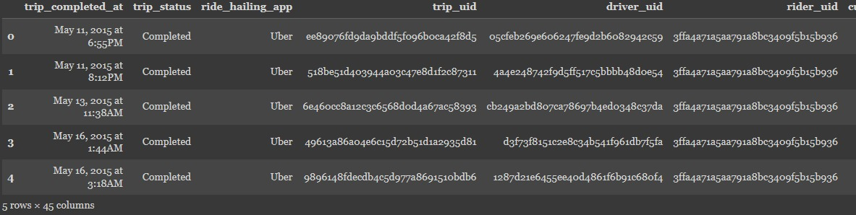**

**DATA CLEANING :-**

**Data cleaning is the process of preparing data for analysis by removing or modifying data that is incorrect, incomplete, irrelevant, duplicated, or improperly formatted.**

**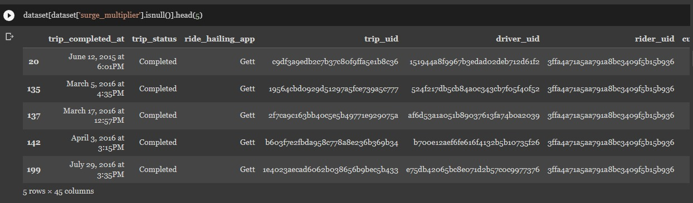**

**DATA PROFILING:-**

**Data profiling is a technique used to analyse and gain a better understanding of raw data. It is the first step in determining what**[**insights**](https://www.datarobot.com/wiki/insights/)**data can yield when you run it through**[**machine learning**](https://www.datarobot.com/wiki/machine-learning/)[**algorithms**](https://www.datarobot.com/wiki/algorithm/)**in order to make**[**predictions**](https://www.datarobot.com/wiki/prediction/)**. Through data profiling, you determine whether the dataset is complete and accurate enough to solve a practical business problem. It is the very first step in**[**preparing**](https://www.datarobot.com/wiki/data-preparation/)**your data for predictive analytics, and it is essential for clarifying the structure, content (**[**features**](https://www.datarobot.com/wiki/feature/)**), and relationships of your dataset for predictive [modeling](https://www.datarobot.com/wiki/model/" \t "_blank).**

**In the Data Profiling section , we were able to take out the output of the trip start address .**

**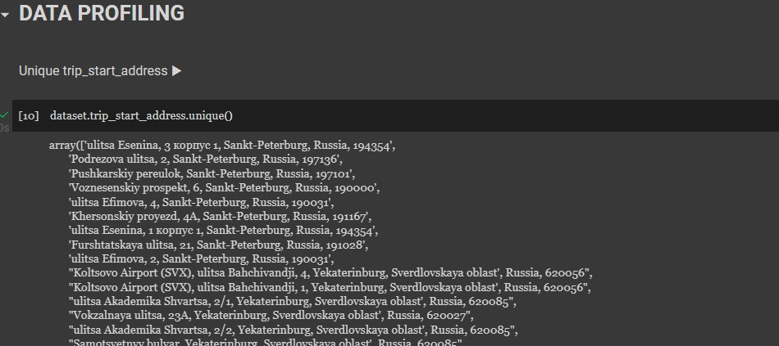**

**DATA PREPROCESSING :-**

**Data pre-processing is a process of preparing the raw data and making it suitable for a machine learning model. It is the first and crucial step while creating a machine learning model.**

**When creating a machine learning project, it is not always a case that we come across the clean and formatted data. And while doing any operation with data, it is mandatory to clean it and put in a formatted way. So for this, we use data pre-processing task.**

**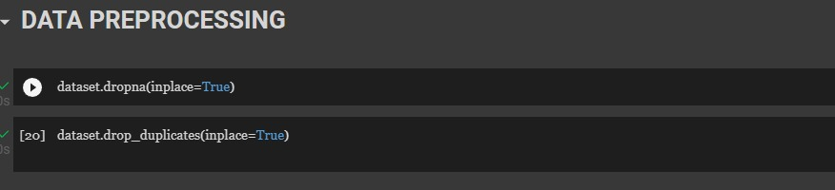**

**DATA VISUALISATION :-**

**Data visualization is the graphical representation of information and data. By using v**[**isual elements like charts, graphs, and maps**](https://www.tableau.com/data-insights/reference-library/visual-analytics)**, data visualization tools provide an accessible way to see and understand trends, outliers, and patterns in data. Additionally, it provides an excellent way for employees or business owners to present data to non-technical audiences without confusion.**

**In the world of Big Data, data visualization tools and technologies are essential to analyze massive amounts of information and make data-driven decisions**.

**INPUT :-**

**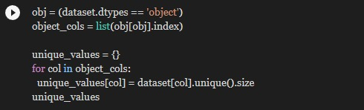**

**Output :-**

{'trip\_completed\_at': 643,

'trip\_status': 2,

'ride\_hailing\_app': 2,

'trip\_uid': 643,

'driver\_uid': 593,

'rider\_uid': 1,

'customer': 1,

'trip\_start\_time': 642,

'trip\_end\_time': 642,

'trip\_time': 548,

'total\_time': 78,

'wait\_time': 451,

'trip\_type': 6,

'vehicle\_make\_model': 119,

'vehicle\_license\_plate': 1,

'driver\_name\_en': 174,

'vehicle\_make': 36,

'vehicle\_model': 117,

'driver\_gender': 2,

'driver\_photo\_url': 1,

'driver\_phone\_number': 1,

'trip\_map\_image\_url': 1,

'trip\_path\_image\_url': 1,

'city': 3,

'country': 1,

'trip\_start\_address': 287,

'trip\_end\_address': 250,

'price\_rub': 390,

'temperature\_time': 642,

'cloudness': 99,

'weather\_main': 9,

'weather\_desc': 13,

'precipitation': 3}

**DATA VISUALISATION USING PLOTTING :-**

**INPUT :-**

**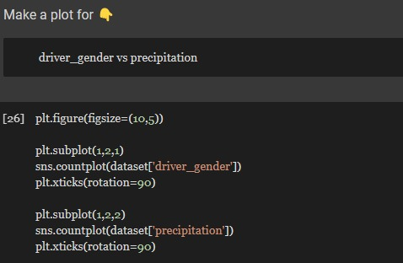**

**Output :-**

**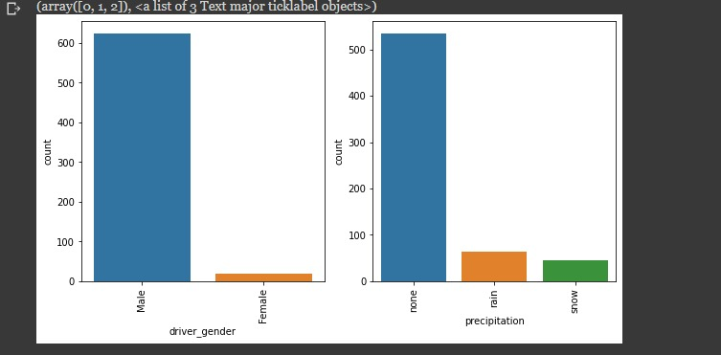**

**DATE TIME OPERATION :-**

**By converting the strings into datetimes, this exposes all the pandas dt properties.**

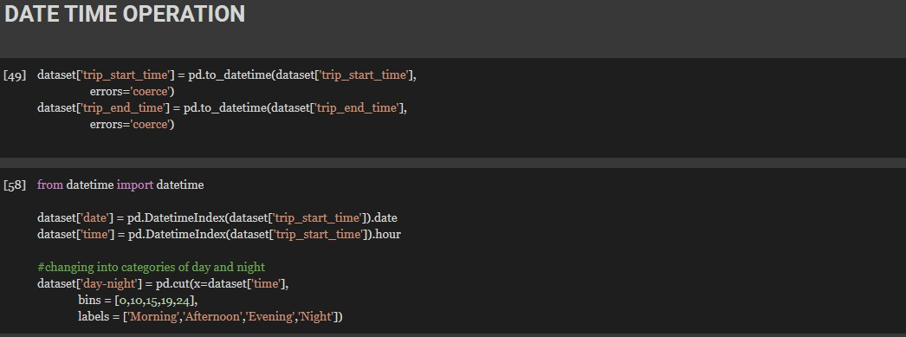

**FUNCTIONAL REQUIREMENTS OF THE SYSTEM**

***SOFTWARE:***

* *Operating System*
* Windows OS 11

***WEB BROWSER:***

* Internet Explorer 7
* Google Chrome

***CODING LANGUAGE :***

* Python

**Conclusion :**

Working with different kinds of data poses a unique challenge each time. Issues might crop up in the data values stemming from the data collection stage or the data storing/retrieval stage. One such challenge for the Uber dataset is that many location columns have NULL values or say “Unknown Location.” When fewer in number, you can delete these rows. But in our case, “Unknown Location” has a high occurrence in the location columns but does not give us any knowledge or insight about the user’s travel patterns. But due to their significance, those rows cannot be ignored unless the rest of the features of those rows are proven to be equally useless.

**REFERENCE**

[**www.interview.projectideas**](http://www.interview.projectideas)

[**www.geesksforgeesks.com**](http://www.geesksforgeesks.com)

[**www.3Dsurfaceplot.com**](http://www.3Dsurfaceplot.com)